ACT Schools Admissions Policy and Procedure
Introduction
ACT Schools is registered as an independent day school with multiple centres designed to offer an alternative education at Key Stages 3 and 4 to young people who have been excluded, are at risk of exclusion, are school phobic or who are classed as vulnerable.
We are equipped to admit up to 150 pupils aged 11 to 16 years, and our school is registered to admit pupils with special educational needs specific to Behavioural, Emotional and Social Difficulties (BESD) and attention deficit hyperactivity disorder (ADHD).
Commitment
ACT are committed to ensuring that all young people are equipped to become successful adults with a wide range of skills and abilities. Through admission to our specific, targeted Schools Programme, we attempt to provide fundamental issue, currently a barrier for far too many young people across Wales.
ACT Schools are committed to, and actively promotes equality of access, a sense of belonging and opportunity for all pupils, regardless of gender, attainment, ethnicity, additional learning needs or competence in English and/or Welsh.
Purpose
The Admissions policy ensures fair access and consideration for all pupils seeking placement within ACT Schools. This policy provides an outline for admissions and induction into the school setting.
Responsibilities
The Head of 11-16 Education and Delivery Director have overall responsibility for this policy and its implementation.
Communication and Storage
The ACT Schools Admissions Policy and Procedure will be stored:
- Externally via the ACT Schools Website
- Internally via IRIS HR, under company information
Procedures
Funding
Places at ACT School can be funded directly by the family of the pupil. Costs are dependent on the type of provision provided and these will be discussed upon referral. At this stage ACT does not offer any support in the form of bursaries.

Pupils who are placed at ACT Schools via the local authority are funded directly by their corresponding authority. Places can either be procured on an individual or group basis.

Criteria for Placement

As a registered independent school ACT are able to admit any pupil between the ages of 11 to 16 years. However, based on the nature of the provision, places are most suited to pupils who have not engaged well with mainstream education, are at risk of exclusion or have behavioural, social or emotion difficulties.

Referral routes
Pupils may be considered for placements:

- Following an in-depth local authority led multidisciplinary assessment, often in the form of Education Otherwise than at School (EOTAS) panel, whereby ACT Schools is deemed an appropriate provision for the pupil.

- Following a statutory assessment, Annual Review and/or the development of an IDP, which identifies ACT Schools as an appropriate provision to meet the pupil needs set out in either the statement/IDP/EHCP to include specific requirements for additional learning provision.

- On arrival into the Local Authority (LA) having previously attended a speciality provision or special school elsewhere.

- Following a direct parental request to ACT Schools.

- In exceptional circumstances, e.g. sudden trauma, or permanent exclusion.

- Following a request from another LA.

Prioritising placements
If there are more pupils who meet the criteria than available places, the following priority rules apply:
- If the pupil is a Child Looked After, and there is evidence that that the placement in ACT Schools will be appropriate to meet their needs

- The current educational placement is no longer sustainable and the child is at risk of not receiving any education

Admissions

ACT Schools would encourage anyone looking to refer a pupil into the provision to:
- Visit the centre for an informal conversation in the first instance
This can be arranged by contacting the Deputy Head of Education via email to: amandabishop@acttraining.org.uk

- If a place is to be requested, then this should be done so, in writing to the Schools Admissions team via email to: schooladmissions@acttraining.org.uk

- One agreed, the following information is required:
  - Referral form
  - Copies of relevant statements/multi agency reports
  - An up-to-date risk assessment
These documents should be submitted to our school admissions inbox (schooladmissions@acttrainig.org.uk)
- Upon receipt of the documents listed above, ACT’s induction process will be instigated (see Annex 1 for ACT Schools Academy process and Annex 2 for Vocational Day provision)

Time Scales

ACT School will commit to processing applications for placements and facilitating successful admissions in a
timely manner.

- ACT Schools will aim to respond to all enquiries within 48hrs.

- The management team sit every Friday to consider referrals and from that we will notify of decision within 2 working days.

- If a placement is agreed there will be a two-week window in which we aim for the admissions process to be completed. This however will depend on initial parent and pupil engagement.

- All new pupils will start with ACT Schools on a phased transition timetable (3 days a week) for two weeks. A PSP will be put in place prior to the pupil starting with ACT Schools. After this period, it will be reviewed and in most cases pupils will join a full-time timetable. If it is deemed necessary, a phased transition may be extended to ensure the successful transition of individual pupils.

Transport

ACT Schools does not manage transport requirements to and/or from school premises for any pupils.
However, some pupils who are referred by local authorities may be entitled to free school transport. This may involve specialised transport, including chaperones, for those with more significant BESD.
ACT Schools encourages all parents/guardians and carers of pupils to check with their local authority for eligibility.

Where public transport is the main mode of transport, ACT Schools maybe able to negotiate group drop off and pick up points to reduce independent journey times. This must be discussed at point of referral.

Monitoring and Reviewing of Placement

Suitability of placement will be reviewed by ACT Schools on a termly basis.

For all pupils with an existing statement of educational needs, an Annual Review will be held within 10 months of the current statement being issued, or the previous Annual Review meeting having taken place. The pupil and their parent/guardians will be involved in all review activities.

For all pupils on the new system for Additional Learning Needs and with an Individual Development Plan (IDP), ACT Schools will work with either the local authority or the maintained school to ensure the IDP is reviewed and updated annually as a minimum. The pupil and their parent/guardians will be involved in all review activities in order to determine the ongoing suitability of any additional learning provision.

Appeals against admissions decisions, or monitoring/review of placement decisions

If a circumstance arrives whereby a parent/guardian or carer is unhappy of a decision as per the ACT Schools Admissions policy/procedure, individuals are required to submit a written appeal detailing the rationale for appeal, and any information deemed pertinent, to the Head of 11-16 Education within 10 working days of an admissions, or monitoring/review decision having been made.

The Head of 11-16 Education will then liaise with the Head of Continuous Improvement (as per the complaints policy) to review the appeal and send a written acknowledgement within 3 working days, and will complete a review of the appeal within 15 working days, upon which time a written response will be provided.
Document / Policy Change Request
All changes to this Policy will be authorised by, or made to the Head of 11-16 Education.
Document / Policy Reviewing and Approving
This document will be reviewed annually by the Head of 11-16 Education.
References
Equality and Diversity Policy
Learner Health and Wellbeing Policy
ALN Policy
Glossary
- Placements
- Pupil – the young person

Annex 1 - ACT’s induction process
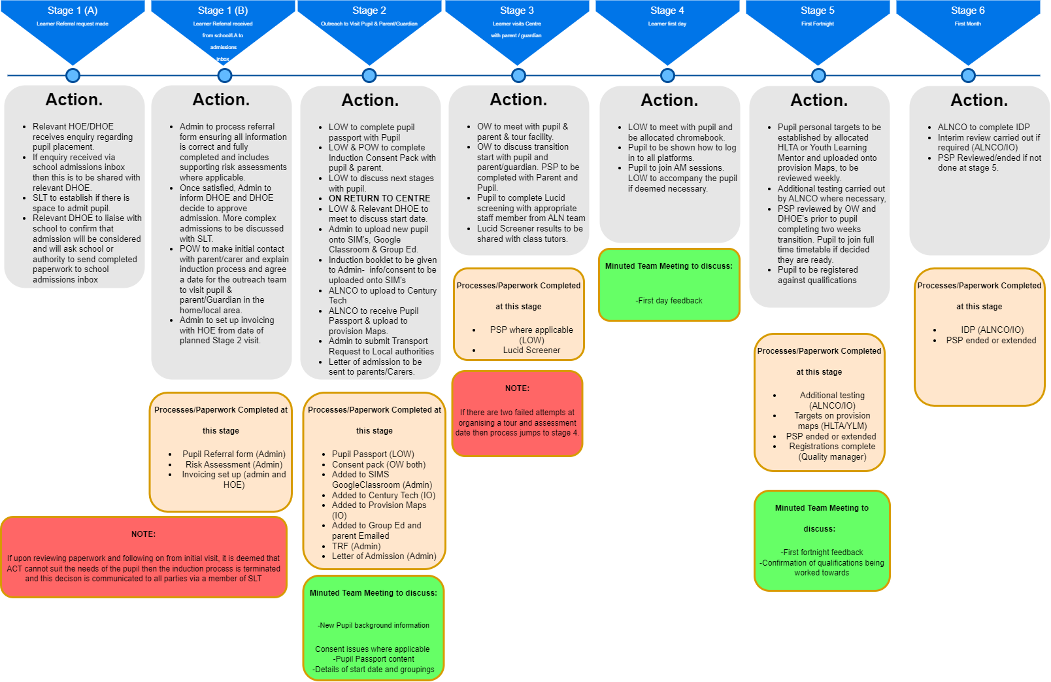

Annex 2 – ACT's Vocational Provision Admissions/Induction Process

